Performance Measurement Frameworks
By
Dr Les Shone
Provost for Africa & The Middle East, Commonwealth University Belize

The Dubai Leadership Summit has been initiated to serve as a forum to inspire leaders, exchange ideas and opinions about practical leadership challenges and to enable leaders to benchmark good practices.
Recent research by the Hay Group has shown that despite the world-wide recession severely impacting organisations operational and financial performance, most of them still have substantial reserves of competency, efficiency and productivity that has yet to be set free from their employees.
To determine how to tap this critical and valuable resource, organisations must:
- Regularly assess leadership effectiveness
- Move away from a command and control style of leadership
- Put leadership development programmes in place to up-skill their leaders
- Hold leaders responsible for creating a motivating work climate within the organisation

By putting these measures in place, creative leaders in organisations who are clear thinkers and have vision will be able to unlock the hidden potential in their employees.
One of the prime areas to unlock employee potential is to introduce a performance measurement system. Most employees who have a sense of responsibility, accountability and commitment to their work respond positively to being measured. The main problem faced by most organisations is to decide on which performance measurement system best suits their particular needs.
This paper is primarily directed at providing a brief overview of some of the more popular performance measurement frameworks that span the spectrum between implementing strategy and the criteria for managing operations processes more effectively and efficiently.

Performance Measures
Recent research conducted by the Centre for Strategic Manufacturing in the United Kingdom states that performance measures must be used to manage the performance of an organisation. The results must be integrated with the organisation’s appraisal and reward system to focus on and develop its employees’ skills, competencies and capabilities.
An overriding consideration that must be understood and accepted is that performance measures have the effect of encouraging specific behaviours. In fact, poor performance measurement and management systems often lead to dysfunctional behaviour.
Performance measures send employees messages about what really matters and how they should behave. When the performance measures are consistent with the organisation’s vision, mission, core values and corporate strategies, they encourage behaviours that are consistent with achieving them.
The right performance measures also encourage implementation of the organisation’s strategic intent and cultural environment. Research conducted at the Cranfield School of Management indicates that ninety-six percent (96%) of the respondents surveyed over a wide range of industry sectors were dissatisfied with their organisations performance measurement system and wanted a major overhaul.
It is important, however, to maintain a balance in the quest for data and accountability. It is easy to end up measuring everything that moves while learning little about what is important. That is one reason why cross-functional processes need owners to decide which measures are important and which metrics will apply, so that judgments can be made upon analysis of the data and appropriate actions initiated.
Competitive pressure worldwide has pushed organisations to implement performance measurement processes as a key approach to assist managers in their efforts to drive major issues and operational strategy to ensure continuous improvement, increased productivity, growth and success.
Most well-managed organisations use key performance indicators to assess and continually monitor their internal performance and external outcomes in regard to quality, quantity, cost and reliability of products and services delivered. Such organisations have clearly defined corporate strategies, key performance areas and business plans to measure their progress against budgets and targets.

MANAGING WITH MEASURES

The core competencies and skills which an organisation must measure to ensure continuous improvement, growth and success in the longer term are the managing of strategy, performance, money, quality, projects, employees & work teams, information & technology, risk, stakeholders and change & growth.
The key objectives and incentives to be derived from measuring operational & financial performance are:
- Deliver the organisation’s business strategy
- Sustain and grow a high performance culture
- Manage performance in the workplace
- Empower employees to achieve their full potential
- Direct employees to perform within a results orientated workplace
- Incorporate the organisation’s values, ethos and competencies into individual and business goals.
- Develop and manage talent in order to build capability for succession planning purposes.
- Assist with the identification of potential management and supervisory candidates

Performance Measurement Frameworks
The challenge for designers of performance measurement frameworks is to ensure that the measures are consistent with the organisation’s overall vision, mission and strategic intent, and support value creation and operational excellence.
To achieve the required level of performance, the organisation must first identify the barriers that exist to produce superior levels of performance and prepare action plans to overcome these barriers.
The most common barriers that organisations encounter in setting up a performance measurement framework are capital constraints, organisation structure, lack of definitive policies and procedures, corporate culture, employee skills and competencies, corporate communications and technology infrastructure.
The key elements of a performance measurement framework that must be monitored and continuously improved are:
- External situation assessment – what are the most attractive opportunities?
- Internal situation assessment – how well positioned is the organisation to exploit them?
- Concept and plans – what concepts and plans must be put in place?
- Strategic direction – what major strategies must be adopted to achieve success?
- Processes and systems – what processes and systems must be installed to ensure success?
- Performance measurement – how does the organisation know it is performing at an optimum level?
To ensure a balanced approach to the preparation of a performance measurement framework, the following design considerations must be taken into account:
- Many organisations have internally focused operational and financial metrics, but few that capture the real needs and desires of their customers
- Few organisations actively manage the evolution of their measurement systems, which is why obsolete measures are rarely detected
- For most organisations, perhaps the most serious problem is that their measures are rarely aligned and integrated, either with each other or with the vision, mission and strategic intent of the organisation
- Measures are frequently criticised for their lack of relevance to the operational strategies and key issues at hand within the organisation
- Less focus must be placed on retrospective performance assessment and more concentration on future performance planning and improvement
- Identification and recognition of the skills and competencies associated with higher levels of performance
- Identification and recognition of outputs which are defined in qualitative terms and not just quantitative ones
- A more mentoring, coaching and counselling style of employee assessment with less emphasis on criticism and perceived weaknesses
- More focus on an individual’s contribution to the overall success of the organisation
The main benefits to be derived from implementing a performance management system are:

- Provides management with a concise view of overall performance against plan
- Provides a framework for setting performance targets for all levels of employees
- Creates an environment for regular communication with employees
- Drives effective utilisation of resources
- Assists to identify skill and competency gaps
- Encourages employees to contribute to the overall planning process
- Formalises the frequency of control, enforces accountability and promotes responsibility.
- Identifies quantifiable and observable achievements that can be measured.

The key success factors to ensure that a performance measurement framework will achieve its objectives are:
- Integrated external and internal performance measures are in place
- An organisation-wide standardised approach to implementation of projects
- Data accuracy – the more the performance measures are used by management, the more reliable and accurate they become
- Information technology support is essential to remove the cumbersome, non-value-adding and time-consuming aspects of performance measurement
- Information should be made available as near to real time as possible
- Simplicity – avoid complicated and inflexible approaches at all costs
- Making performance measurement part of an employee’s job description is an essential prerequisite to success – this way everybody is involved
- Top management commitment and participation is of paramount importance without which you do not get out of the starting blocks
- The performance measurement system must be used as the primary management reporting tool at all levels and used to drive improvement programmes.
Despite all the systems that are available, a large number of the current performance measurement frameworks still fall short of providing true value, primarily due to their inability to:
- Expand revenue opportunities and improve cost structures
- Provide for diversification of business opportunities
- Enhance customer focus and customer value
- Increase utilisation of assets and reduce waste
- Improve productivity and increase efficiency
- Drive financial performance and operational effectiveness
- Install the right processes to match customers and the organisation’s business needs and expectations
Poor performance measurement frameworks tend to provide too much information that hampers decision-making, they are not structured to fit the organisation, they reflect functions and not business processes and in certain circumstances, reinforce the wrong behaviour.
The performance measurement frameworks, systems, techniques or approaches covered in this paper are:
- Cost and Management Accounting Techniques
- The Balanced Scorecard
- European Foundation for Quality Management
- Integrated Performance Measurement System
- The Performance Prism
- Business Growth Model
- The Supply Chain Operations Reference Model
- The Product and Cycle-Time Excellence Model.

Cost and Management Accounting Techniques
The performance measurement movement started with the realisation that cost and management accounting techniques alone no longer provided adequate control mechanisms to facilitate the efficient and effective management of a modern organisation. Johnson and Kaplan in their book “Relevance Lost – The Rise and Fall of Management Accounting” clearly outline the shortcomings of cost and management accounting practices to manage the performance of modern organisations.

Relevance Lost was a catalyst for change in cost and management accounting research and, in particular, research on the development of cost and management accounting thought and practice. It encouraged the development of cost allocations and performance measures consistent with modern manufacturing and business practices.
The argument in Relevance Lost is a peculiar mixture of normative and positive perspectives. Its fundamental theme is that cost and management accounting change is motivated by the search for efficiency and profit. The loss of relevance of cost and management accounting to manufacturing and business operations suggests that either the market mechanism failed or there was no cost and management accounting innovation on which the market could act.
Johnson and Kaplan concluded with an appeal to the cost and management accounting academics to develop new measurement techniques to help current managers identify and monitor efficient business processes and specifically manufacturing processes.

The BalanceD Scorecard
Kaplan then teamed up with Norton to develop the balanced scorecard, which has enjoyed worldwide recognition and acceptance. Since it was first published in 1992, the balanced scorecard has developed into a performance measurement framework to turn strategy into action. It translates vision, mission, core values, ethics, strategies, legislation, external impacts and long-term business direction into strategic objectives (performance drivers).
These performance drivers provide an early warning system for management by measuring progress against the prioritised performance goals, short-term operational goals and strategic initiatives of the organisation to meet future business opportunities and challenges.
The balanced scorecard is primarily used as an implementation tool that helps focus on the key business areas and performance drivers of corporate strategy and is used to communicate the strategic direction of the organisation to all levels of management and staff. It also provides feedback on internal business processes and external outcomes to improve strategic performance and operational results.
This measurement and management process also satisfies shareholder and stakeholder expectations by incorporating both financial and operational concerns including behavioural issues such as absenteeism and labour turnover. The process is based on strategic objectives that are continuously tracked over time to determine trends, best and worst practices and areas for decision making to increase financial efficiency, enhance service delivery and improve operational processes and productivity.
This management process derives its strength by identifying key performance areas with associated key performance indicators and appropriate targets for each strategic objective of the organisation as a basis for evaluating performance.
The process also acts as a strategic map that helps focus on the major business areas and performance drivers of corporate strategy. It also provides a platform to promote competitiveness amongst operational business units.
It is often asked - what must be balanced in a balanced scorecard. A “balance” must be provided between:
- Short- and long-term goals and initiatives
- Diagnostic and strategic measures
- Financial and non-financial measures
- Lagging and leading indicators
- Internal and external performance perspectives
- Resources (inputs) and results (outputs)
- Financial control to strategy focused control
- Qualitative and quantitative data.
When the balanced scorecard within an organisation is fully developed and used to its full potential, it becomes an ideal tool to transform the strategic planning process from an intellectual exercise into the driving force of the organisation.
I have worked with a number of organisations recently where after conducting an in-depth analysis of the shareholders and stakeholders needs and expectations as part of the strategic planning process, it became apparent that the four traditional balanced scorecard perspectives, namely; financial, customer, internal processes and learning and growth, would be inadequate to exercise the range of control required to effectively manage all the organisation’s business operations.
To counter this situation, the balanced scorecard process was enhanced to accommodate two additional perspectives:
- Environment and Community
- Shareholder / Stakeholder Satisfaction
The strategic intent for the environment and community perspective is to take the lead in the use of materials, technologies and processes that are the least damaging to the environment and to enhance the caring image and value the organisation places on the upliftment of and full participation with the community in which it operates.
The strategic intent for the shareholder / stakeholder satisfaction perspective is to instil a culture of high performance and perseverance amongst all employees and to offer mutually beneficial opportunities that will satisfy and add value to organisation’s shareholders and stakeholders, namely employees, customers, suppliers, contractors, government agencies, regulator, investors and the broader community.

Finally, once the balanced scorecard is in place in the organisation, the key performance measures and targets can be benchmarked against external competitors and similar industry sectors in regard to quality, quantity, cost and reliability of products and services delivered.
As with all improvement strategies, metric benchmarking is not a one-time event, but a continual cycle of improvement. It must be performed regularly and consistently to document progress and highlight new management challenges. It should be noted however, that most organisations do not implement benchmarking projects primarily due to time and cost constraints.

European Foundation for Quality Management
During the mid 1990s, with the influence of the quality movement and increasing significance of social and environmental considerations, the need for a broader shareholder and stakeholder approach to performance measurement was recognised.
To accommodate these changing requirements, ordinary organisations were implored to strive to satisfy their shareholders and stakeholders by what they achieve, how they achieve it, what they are likely to achieve and the confidence they have that the results will be sustained in the future to make them into excellent (quality) organisations.
Being “excellent” requires total leadership commitment and accepting a set of principles (fundamental concepts) on which the organisation bases its behaviours, activities and initiatives. When the organisation turns them into practice, it opens access to sustained excellence.
To ensure that the results can be sustained, there must also be evidence that defines what the organisation does and how it does it, is soundly based, systematic and continuously reviewed and improved.
To help guide an organisation to improve its performance, the European Foundation for Quality Management created the EFQM excellence model. The model very effectively captures the point that key performance results are a function of satisfied people and satisfied customers and have a positive impact on shareholders / stakeholders. All of these are required to have efficient and effective business processes.
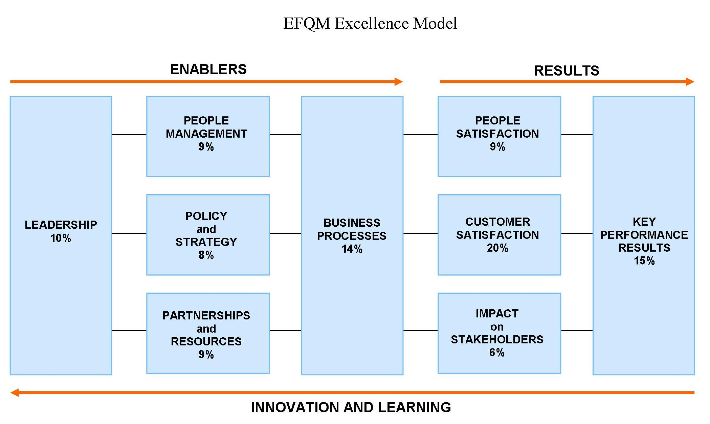

Excellence is not a theory. It relates to the tangible achievements of the organisation and that these will be sustained in the future. For an organisation to be successful, regardless of sector, size, structure or maturity, it must establish an appropriate performance measurement framework.
The EFQM model recognises that there are many approaches to achieving sustainable excellence in all aspects of performance. It is specifically based on the premise that excellent results with respect to performance, customers, people, partnerships and society are achieved through leadership driving policy and strategy.
For an organisation to gain the benefits of adopting such a model, the fundamental concepts of excellence need to be understood and accepted by the management. These concepts, in no particular order of importance, are:
- Results Orientation – achieving results that add value to the organisation’s shareholders /stakeholders
- Customer Focus – creating sustainable customer value
- Leadership and Consistency of Purpose – visionary and inspirational leadership, coupled with consistency of purpose
- Management by Processes and Facts – managing the organisation through a set of interdependent and interrelated systems, processes and facts
- People Development and Involvement – maximising the contribution of employees through their development and involvement
- Continuous Learning, Innovation and Improvement – challenging the status quo and effecting change by utilising learning to create innovation and improvement opportunities
- Partnership Development – developing and maintaining value-adding partnerships
- Corporate Social Responsibility – striving to understand and respond to the expectations of shareholders and stakeholders

Integrated Performance Measurement System
As part of the Centre for Strategic Manufacturing’s on-going research programme into performance measurement frameworks, they recognised the trend towards shareholder / stakeholder, community and environmental involvement by organisations and developed the integrated performance measurement system (IPMS) reference model.
The model was developed on the balanced scorecard approach after recognising the relationships and inter-dependencies between the various perspectives. It was not based on the EFQM excellence model, although some key concepts were embraced in the design criteria.
The IPMS reference model, having recognised the above relationships, restructured the dimensions of performance measurement into four main groups:
- Business Measures
- Business Unit Measures (customer-facing measures, taking into account different customer groups with different competitive requirements)
- Core Process Measures (those processes that add value, such as get order, fulfil order, develop product and support product)
- Support Process Measures (those processes that exist only to support the core processes, such as Human Resources, Finance, Information Technology, and Marketing).
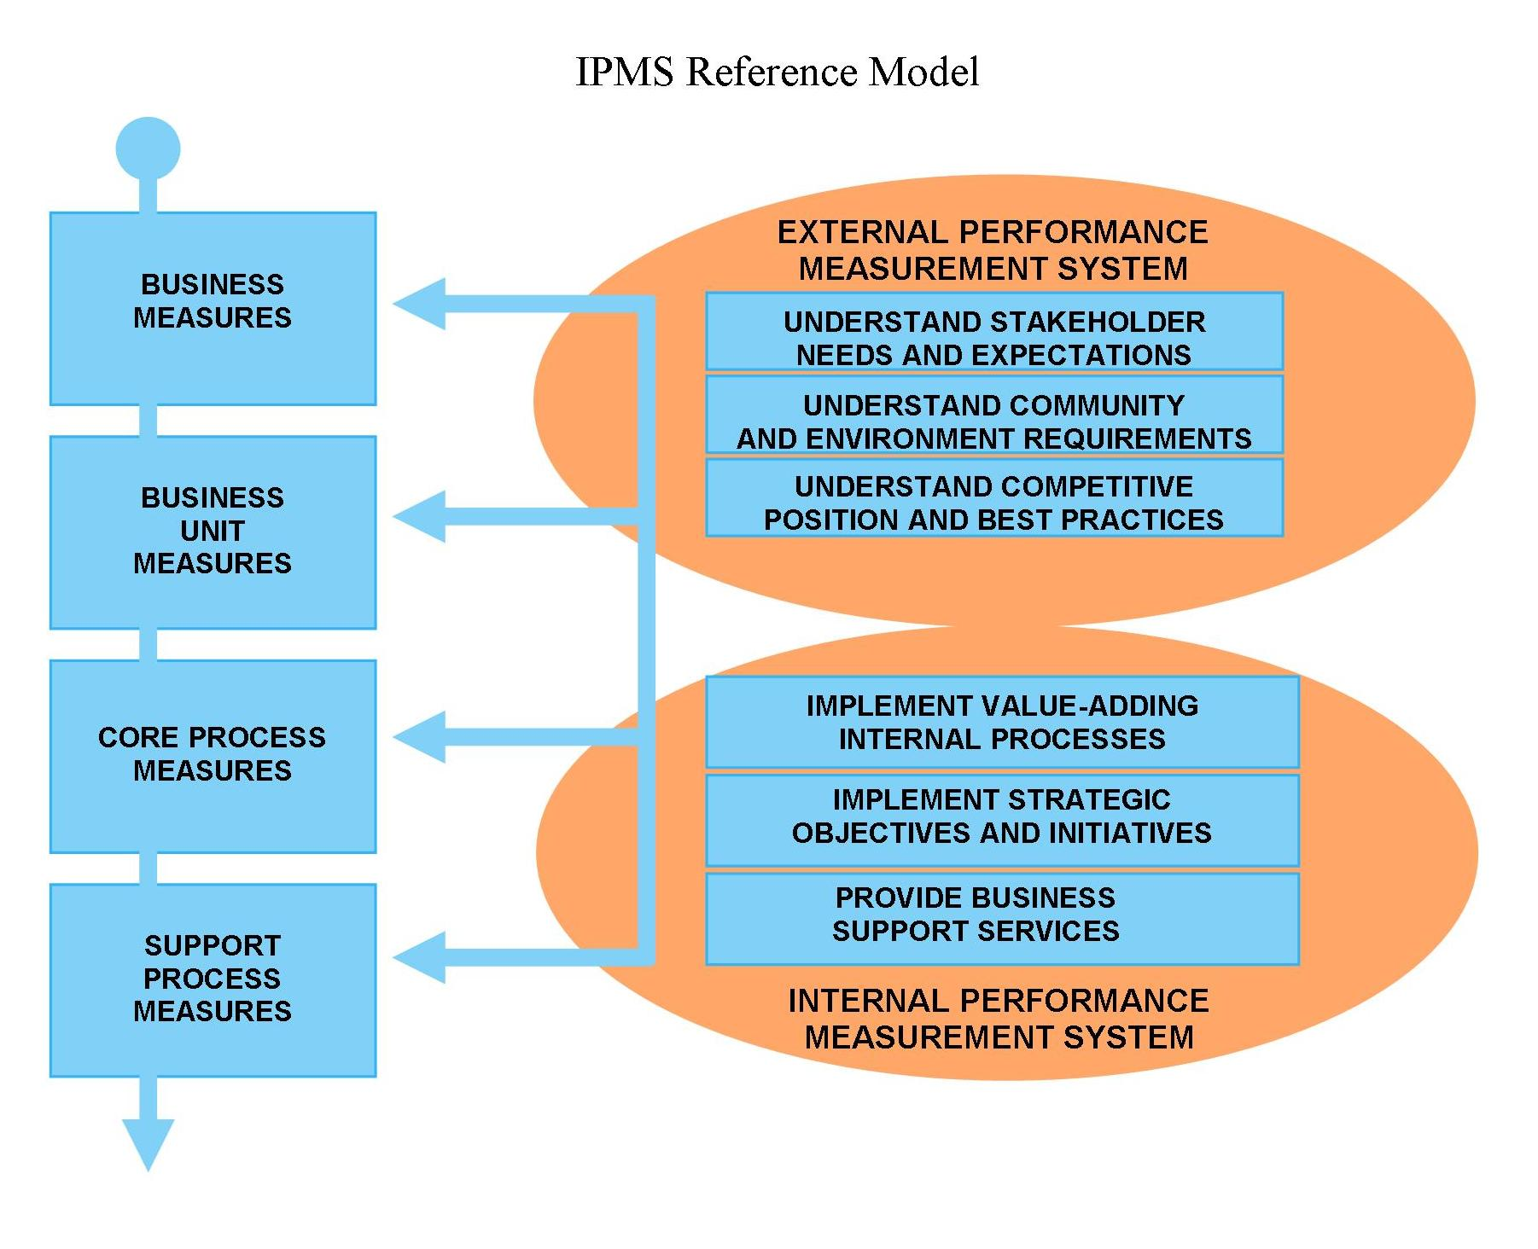

The IPMS reference model also highlighted the need for an external, as well as an internal performance measurement system.

The external performance measurement system is responsible for recognising the needs, expectations and requirements of all the stakeholders, community and environment and establishing the competitive position of the organisation by determining its position with respect to world-class best practices.

This information, together with value-adding internal processes and corporate strategic objectives and initiatives, helps to shape internal priorities and provide business support services. These are then deployed to the relevant parts of the organisation using the internal performance measurement system.

The Performance Prism
High-profile corporate collapses have led shareholders to question whether their investments are in safe hands, with the resultant knee-jerk focus on corporate governance reforms. After analysing the shortcomings of the balanced scorecard, the EFQM excellence model and the IPMS model, Neely and Adams developed and tested an innovative performance measurement framework, referred to as the performance prism, to plug the identified gaps.
Increasingly, executives and senior management believe that the only sustainable way for an organisation to survive and thrive in the 21st century is to successfully manage the relationships with each of its major shareholders and stakeholders – typically investors, customers, employees, suppliers, contractors, regulator, government agencies and the local communities in which it operates. This broad vision of having responsibilities to all shareholders and stakeholders is the new spectrum of business management.
This performance measurement framework helps an organisation to design, build, operate and refresh its performance measurement systems in a way that is relevant in today’s relationships with its multiple shareholders and stakeholders within the context of its operating environment.
It specifically addresses an organisation’s relationship with all its key shareholders / stakeholders and links this to the organisation’s strategies, processes and capabilities.
Neely and Adams claim that this performance measurement framework is the first of the second-generation performance measurement and management frameworks.
It consists of five interrelated outlooks on performance measures that pose vital questions:
- Shareholder / Stakeholder Satisfaction – who are the organisation’s key shareholders and stakeholders and what do they need and expect?
- Shareholder / Stakeholder Contribution – what does the organisation need and expect from its shareholders and stakeholders on a reciprocal basis?
- Strategies – what strategies does the organisation need to put in place to satisfy the shareholders and stakeholders needs and expectations?
- Processes – what processes does the organisation need to put in place to enable it to execute its strategies?
- Capabilities – what capabilities does the organisation have or need to put in place to allow it to operate and improve these processes?
By answering these five questions, an organisation can build a structured business performance measurement model.

One of the advantages of the performance prism framework is that it highlights which outlooks should be covered in a strategy map (Neely and Adams refer to them as success maps) and how they need to cascade them through the organisation.
A success map is the output of a process developed through a series of cross-functional management workshops, which usually benefit from independent facilitation. The objective is to identify the critical links between the needs and expectations of a stakeholder, the organisation and the strategies, processes and capabilities that must be in place to satisfy the specific needs and expectations.
At an individual stakeholder group level, different customer segments might be identified that require different strategies, processes and capabilities that must then be integrated into a simplified overall business performance measurement model. While the creation of such a model that is specific to the individual organisation may seem obvious, in many organisations it can be a real revelation and a means of focusing management’s attention on critical components and business issues that require attention
In essence, by applying the performance prism framework, success maps are a means of prioritising where measurement efforts need to be focused. This must allow managers access to relevant data and analysis to address critical questions about managing the organisation or their business units more successfully, both in the short and long term.
A means of validating the outputs from the success mapping process is to apply what Neely and Adams call a “failure map” or “risk map.” Failure/risk mapping checks whether all the critical aspects of performance measurement have been properly addressed. In essence, this technique takes the reverse approach to a success map by identifying particular scenarios that describe the opposite of success – failure.
By examining each key failure exposure, a check can be made on the strategies, processes and capabilities that relate to a particular risk and whether the measurements already selected are sufficient to identify and mitigate the risk’s occurrence. To be forewarned is to be forearmed.
The performance prism approach assists users to think more broadly about the needs and expectations of all their stakeholders. The framework forces them to explore what strategies, processes and capabilities they must have to deliver value to each of their stakeholders groups.
Often these organisations realise that some of their strategies are incomplete, their processes are inappropriate, or their capabilities are lacking. This forces senior management to think about how they will review their organisation to ensure it is in a better position to compete in the future.
BUSINESS GROWTH MODEL
Research continued into developing second-generation performance measurement and management frameworks. Bititci of the Centre of Strategic Manufacturing in the United Kingdom then teamed up with Turner to develop a competitive business structure (growth model) for organisations that states that all business operations are comprised of three different process types:
- Manage Processes – concerned with managing the performance of the organisation by setting long-term business direction, evaluating external impacts and perspectives, formulating vision, mission, core values and corporate strategies, and defining operational and financial performance goals
- Operate Processes (customer-facing) – concerned with delivering value to the customer and creating competitive advantage for the organisation. These processes are get order (or create demand), fulfil order, develop product and supply product
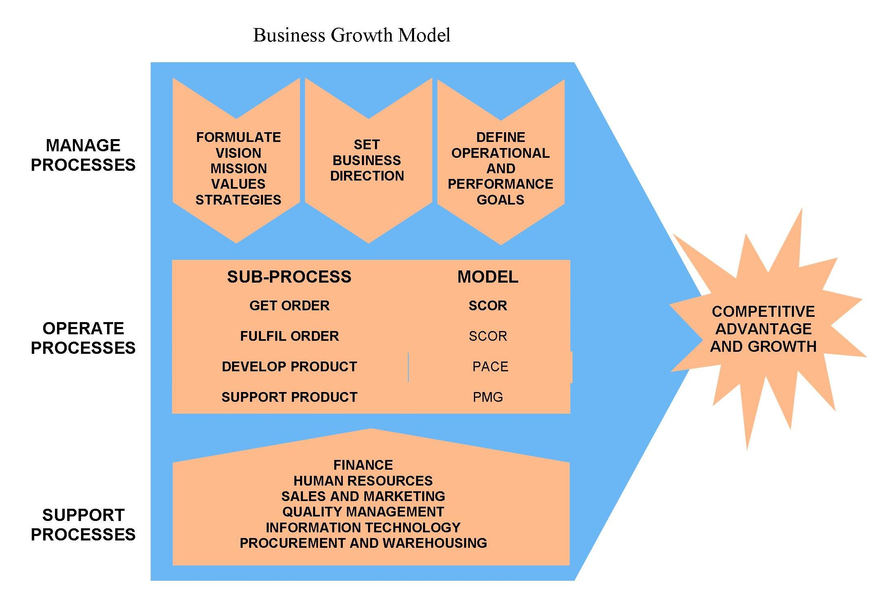
- Support Processes – exist only to support the manage and operate processes. Support processes are Finance, Human Resources, Quality Management, Information Technology, & Procurement.
The operate processes noted above which demand the most attention are the get order, fulfil order and develop product processes. The Supply Chain Operations Reference (SCOR) model and the Product and Cycle-Time Excellence (PACE) model are the most appropriate models to measure performance of these operate processes.

The Supply Chain Operations Reference Model
The supply chain operations reference (SCOR) model provides a set of performance metrics and supply chain practices where the supply chain performance is contingent on the maturity of supply chain practices. This model allows the organisation to relate the weaknesses in its supply chain performance to its supply chain practices.
This model is endorsed by the International Supply Chain Council, an independent not-for-profit corporation, as the cross-industry standard for applying and advancing state-of-the-art supply chain management systems and practices.
The model was developed from pooling a large number of organisations real-world supply chain experiences to build a flexible framework and common language that assists organisations to improve their internal and external supply chains.
SCOR is a process reference model that integrates the concepts of business process re-engineering, benchmarking and process measurement into a cross-functional framework to evaluate the efficiency of supply chain operations, to measure the performance of specific process operations and to test and plan future process improvements.
The model contains standard descriptions of management processes, a framework of relationships among the standard processes, standard metrics to measure process performance, management practices that produce best-in-class performance and standard alignment of features and functionality.
The SCOR model covers the following three major functions:
- Customer Interaction – order entry through to paid invoice
- Product Transactions (physical, material and service) – supplier’s supplier to customer’s customer, including equipment, supplies, spare parts and bulk product
- Market Interactions – understanding of aggregate demand to fulfilment of order.

At the top level, SCOR is based on five core management processes:
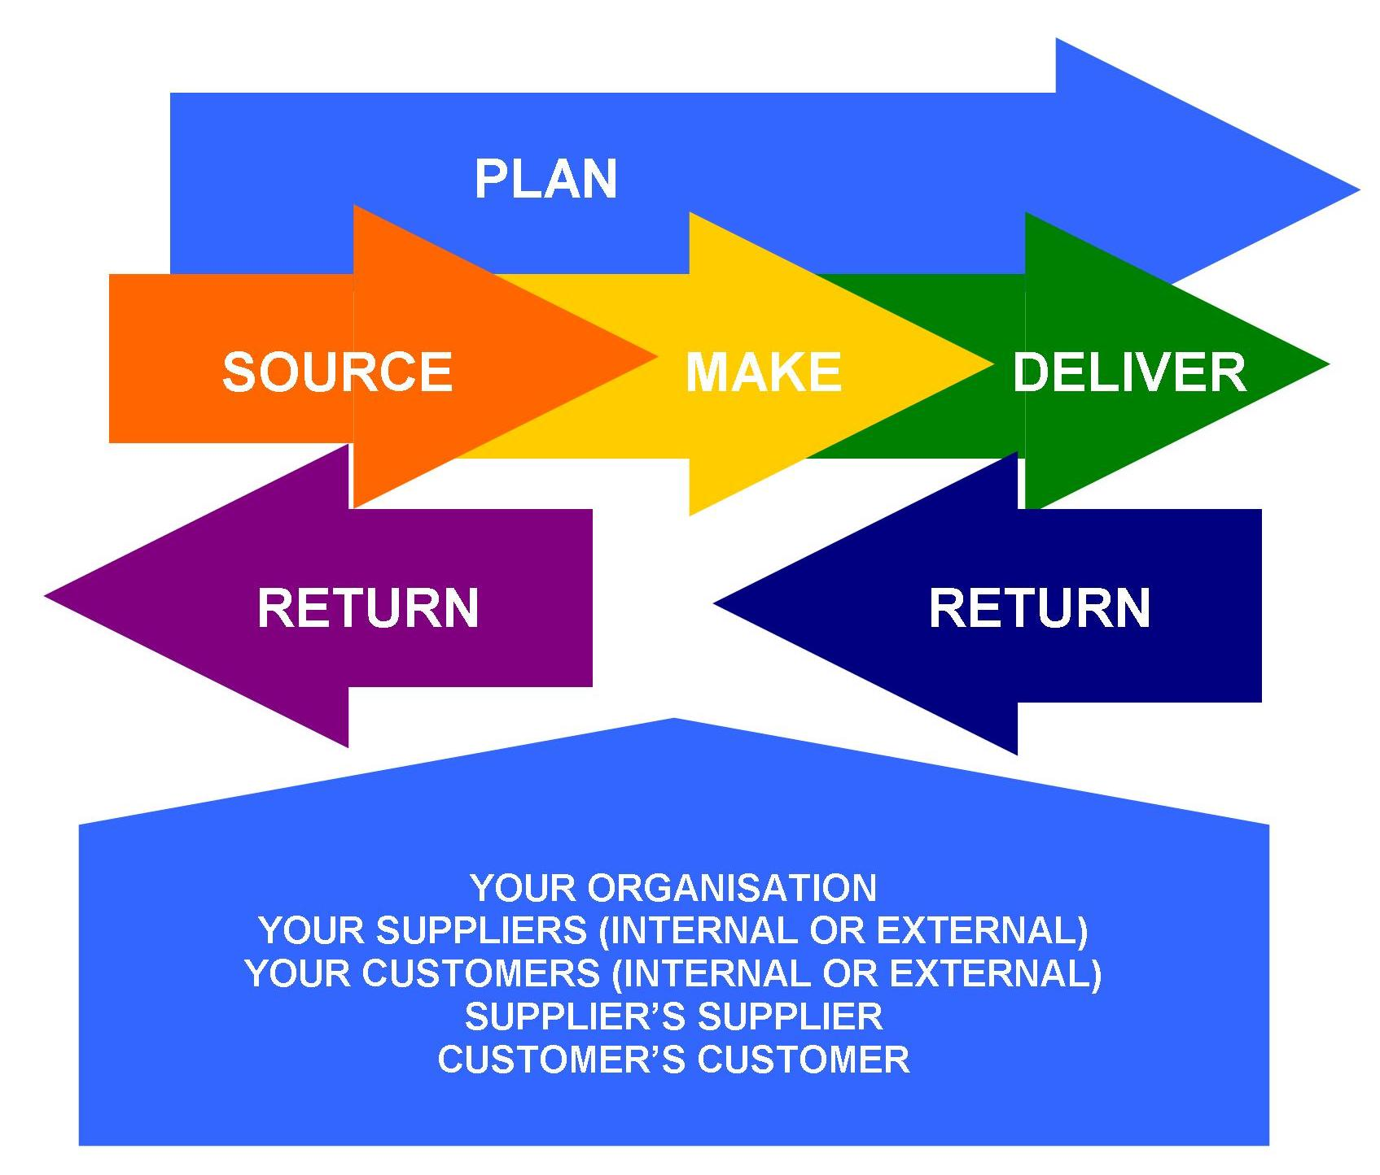
- Plan – processes that balance aggregate demand and supply to develop a course of action which best meets sourcing, production and delivery requirements
- Source – processes that procure goods and services to meet planned or actual demand
- Make – processes that transform product to a finished state to meet planned or actual demand
- Deliver – processes that provide finished goods and services to meet planned or actual demand
- Return – processes associated with returning or receiving returned products for any reason and include post-delivery customer support.

At level two, each core management process is described by three process types:
- Planning – a process that aligns expected resources to meet expected demand requirements
- Execution – a process triggered by demand that changes the state of material goods and generally involves moving product to the next process
- Enable – a process that prepares, maintains or manages information or relationships on which planning and execution processes rely.
Level three defines the organisation's ability to compete successfully in its chosen markets. It consists of process element definitions, inputs and outputs, process performance metrics and best practices with supporting system capabilities. Organisations normally “fine tune” their operational strategies at level three.
Level four defines practices to achieve competitive advantage and to adapt to changing business conditions. Organisations implement specific supply-chain management practices at this level.

The Product and Cycle-Time Excellence Model
The PACE model was developed by PRTM Management Consultants, the original developer of the SCOR model, to address the develop product process. It has a structure similar to that of the SCOR model, that is, it provides a set of product development metrics and practices where performance is contingent upon the maturity of these product development practices.
The PACE framework ensures product development by bringing new products and services to the market. PRTM Consulting has also introduced a model for product support through its sister organisation, the Performance Measurement Group (PMG) based in the United States.

Conclusion
It really does not matter which performance measurement framework an organisation uses. There is strong evidence that organisations that are managed through measures achieve higher performance and operational results than those who do not use performance measures.
Most employees who have a sense of responsibility, accountability and commitment to their work, respond positively to being measured. By putting these performance measures in place, creative leaders will be able to unlock the hidden potential in their employees.
Most well-managed organisations use key performance indicators to assess and continually monitor their internal performance and external outcomes in regard to quality, quantity, cost and reliability of products and services delivered. Such organisations have clearly defined corporate strategies, key performance areas and business plans to measure their progress against budgets and targets.

One of the great fallacies of performance measurement design is that performance measures should be derived from strategy. Listen to any conference speaker or read any management text on the subject and generally the statement will be made: “Derive your performance measures from your strategies.” This is such a conceptually appealing notion that nobody stops to question it.
In reality, strategies are reactions to opportunities or threats in the organisation’s operating environment. Understanding the organisations operating environment must therefore be the starting point. Knowledge of the shareholders and stakeholders’ changing needs and expectations and how well the organisation is satisfying them is the output of prior strategies and the basis for new strategies.
Key shareholders are the organisation’s investors and key stakeholders are the organisation’s employees, customers, suppliers, contractors, government agencies, regulator and the community. There is a growing trend, not only for stakeholder involvement but also a commitment to assess and incorporate social and environmental considerations.
Organisations need to focus on long-term growth and sustainability and avoid the pressure to over deliver today at the expense of tomorrow. There is fundamentally no inconsistency between the pursuit of sustainable growth and the commitments to shareholders and stakeholders, as therein sits part of the organisation’s long-term competitive advantage.
The role of organisations in society is now coming under intense debate. The global consensus appears to converge on the fact that “responsible organisations” are net contributors, not only for their shareholders (in terms of incremental wealth creation) but also for those who work for them, the stakeholders - employees, business partners and society.
Their “contributions” must be made in a manner that is sustainable. The main challenges facing organisations today are essentially survival, creating wealth for shareholders and sustaining an organisation that would continue to deliver value over the long term.
The economic rationale behind the philosophy of sustainable growth is not too difficult to understand. Successful organisations, over time, will not be those who maximise short-term results but those who invest for superior returns in the future. Herein a dilemma exists – in order to survive, the future organisations need to generate reasonable results today, while pursuing their longer-term ambitions.
Accommodating both perspectives radically changes the agenda of organisations. The factors that contribute to today’s results are not necessarily the key success factors that will build the long-term competitive advantage of the organisation. Competitive advantage, as we all know, is about longer-term uniqueness that differentiates the organisation from its competitions.
Most organisations tend to base their business performance measurement frameworks / models on the foundation of increasing profitability. This is often driven by the short-sightedness of avaricious shareholders who confuse increasing profitability with a measure for success. They give little thought to the aspirations of the stakeholders and to the sustainability of the “increasing profitability” model.
Global experience is witness to the fact that long-standing, responsible organisations are able to deliver their “value added” promise to society only when their business philosophy takes a balanced view that benefits all the stakeholders, not just the shareholders, and when they deploy tactics that can be sustained over a period of time.
The challenge for designers of performance measurement frameworks is to ensure that the measures are consistent with the organisation’s overall vision, mission and strategic aims and support value creation and operational excellence.

To achieve the required level of operational excellence, the organisation must first identify the barriers that exist to produce superior levels of performance and prepare action plans to overcome these barriers.

References
Johnson HT and Kaplan RS, Relevance Lost – The Rise and Fall of Management Accounting
Kaplan RS and Norton DP, The Balanced Scorecard – Measures that Drive Performance
Bititci US and Turner TJ, The Viable Business Structure
Bititci US, Managing with Measures
Neely A and Adams C, The Performance Prism
Supply Chain Council, Supply Chain Operations Reference (SCOR) Model Version 7.0
European Foundation for Quality Management, EFQM Excellence Model
PRTM Management Consultants, Product and Cycle-Time Excellence (PACE) Model

